EX5-Create a simple cloud software application for Mark Sheet Processing System using any Cloud Service Provider to demonstrate SaaS include the necessary fields such as name of the student, Reg no of the student, Subjects , Marks, Average, percentage, rank, overall performance etc.

PROCEDURE:

Step 1: create a new application and name it as score

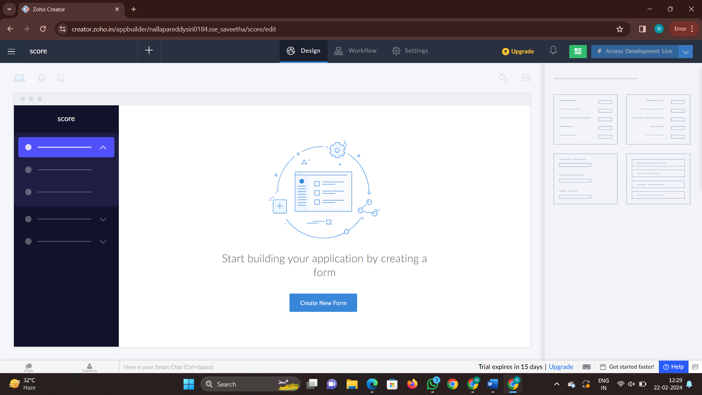

Step 2: now create a form to fill the details

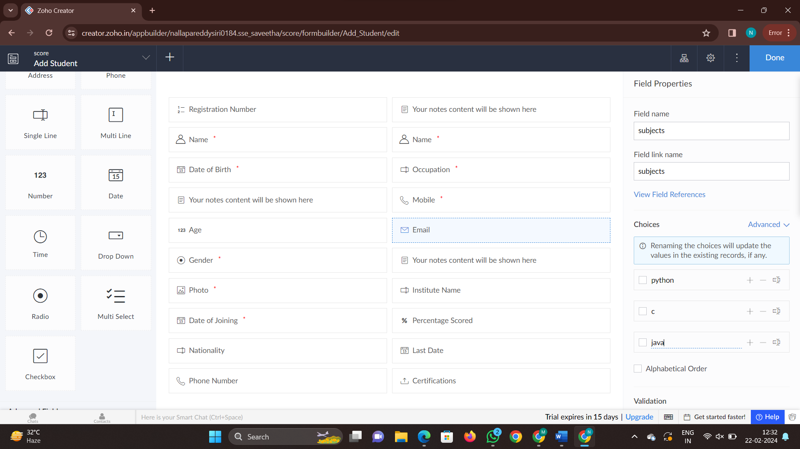

Step 3: Now add another form that is marks which gives details of marks

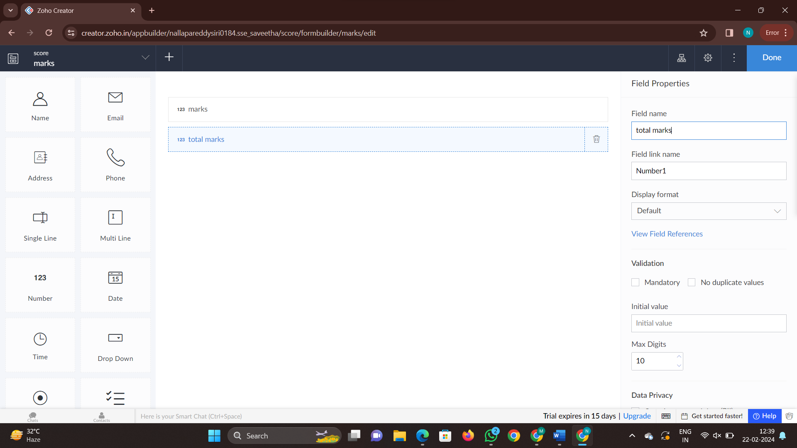

Step 4: Now click on done and check all the given contents are correct or not

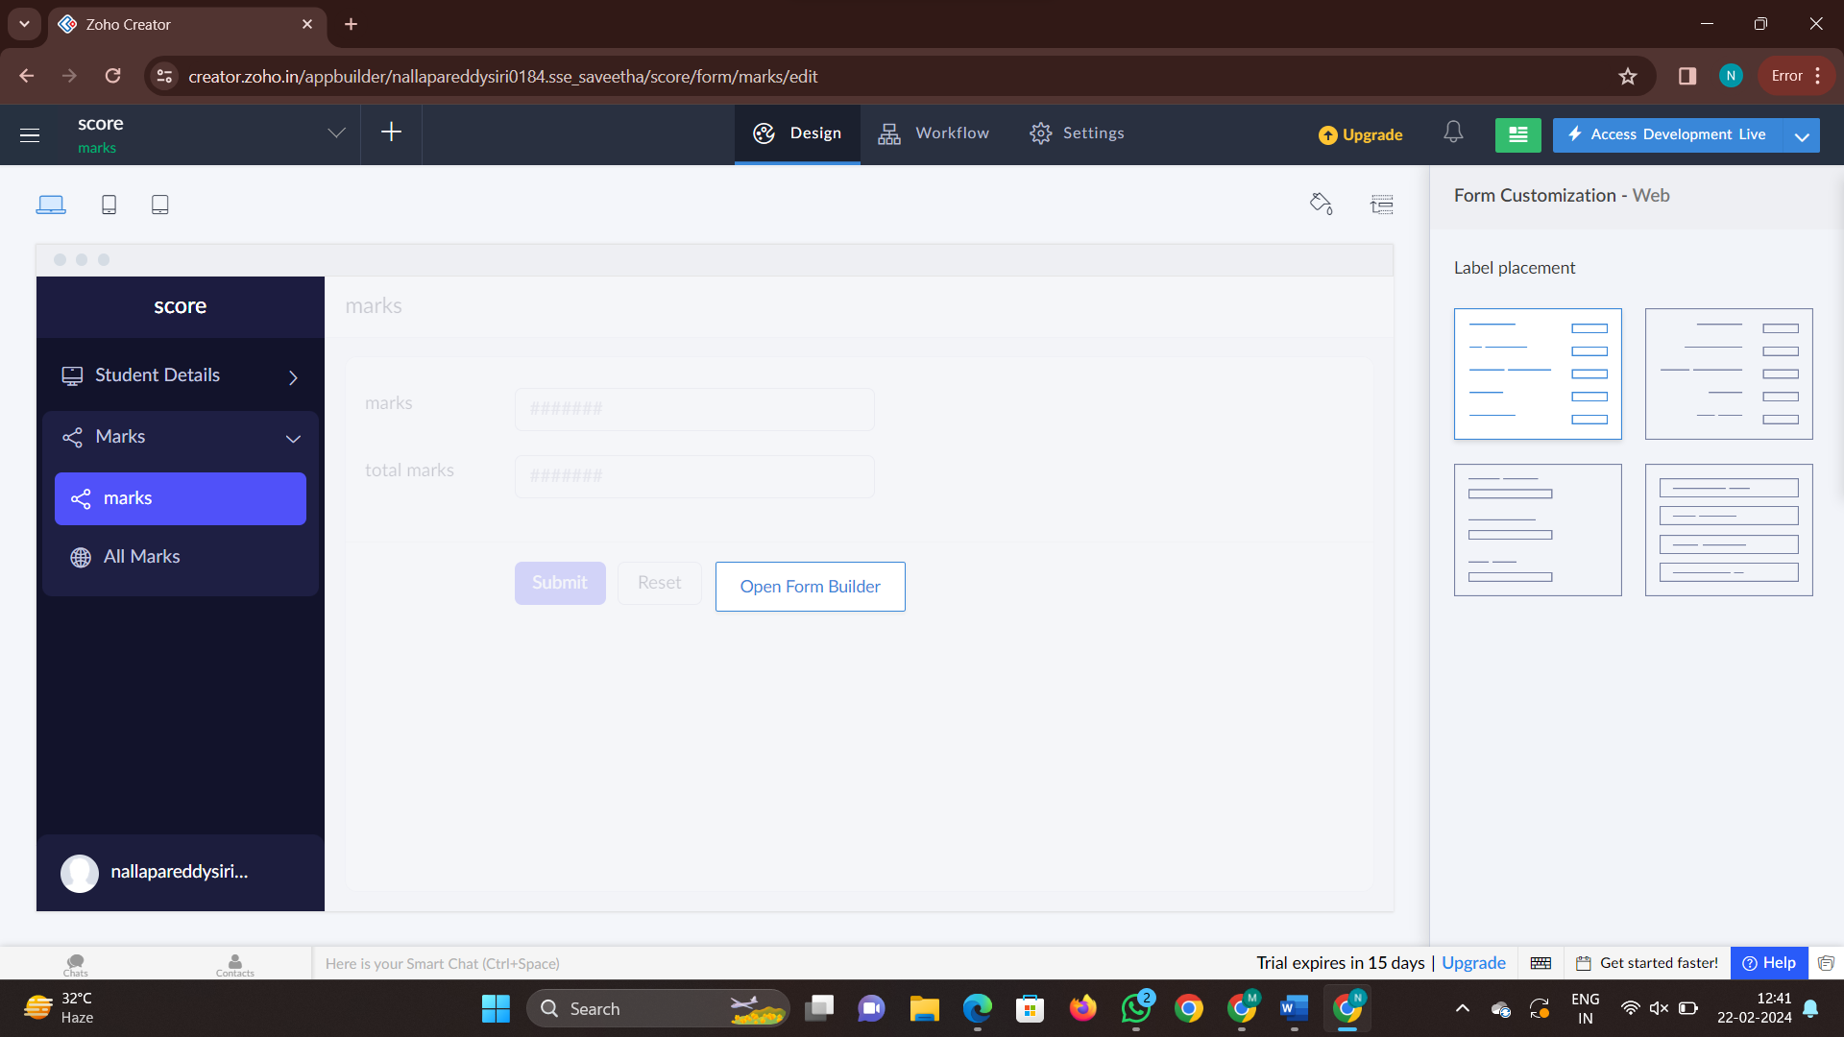

Step 5: add another form named as total grade

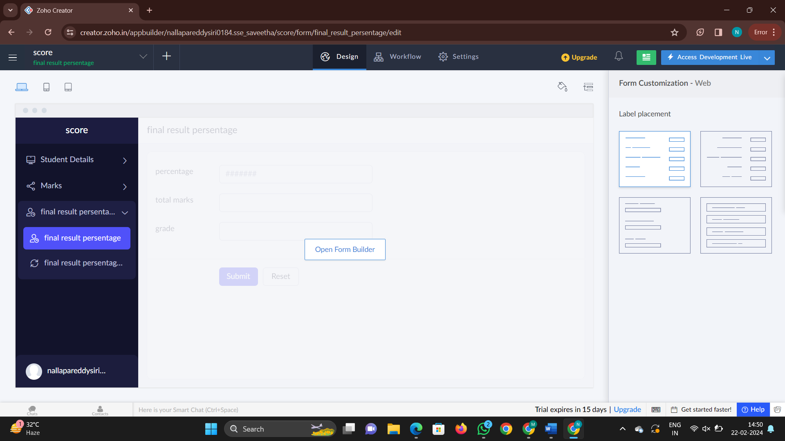

Step 5: Now click the access development live to access the application and give the details

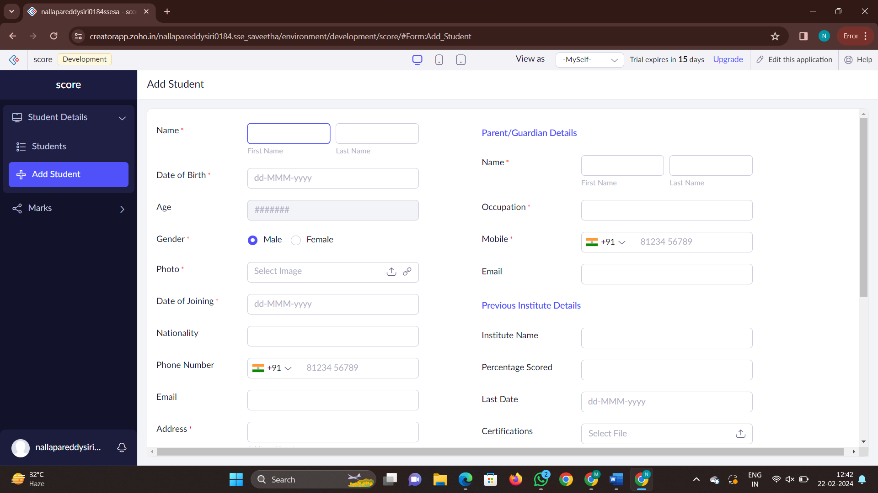

Step 6: Now check the report after filling all the details in the form

